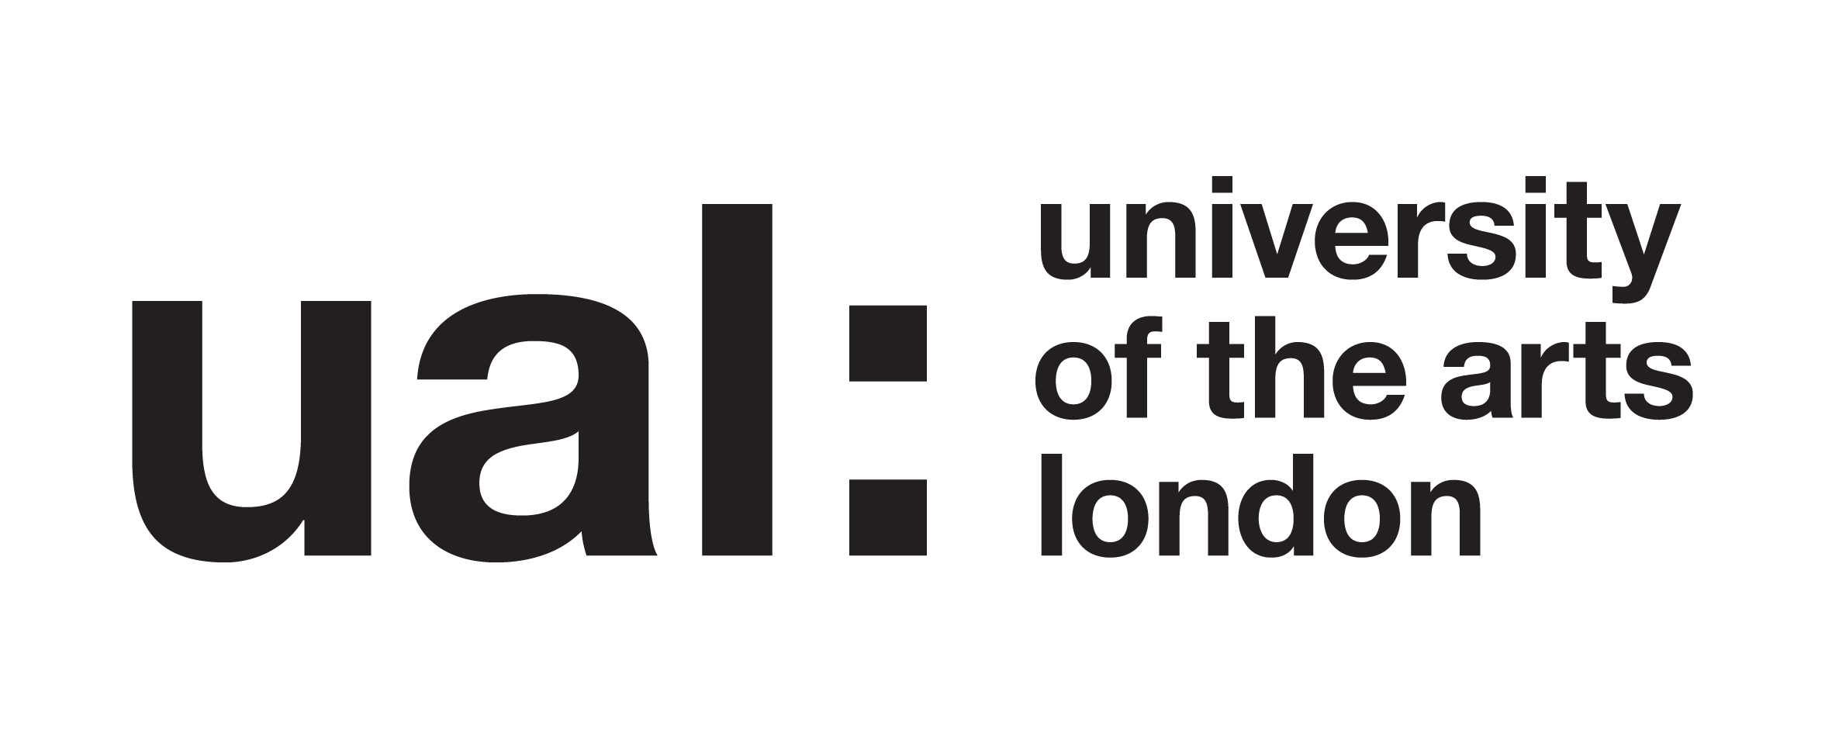

Research project: How can a weekly Year meeting with a large cohort develop a culture of inclusion, belonging and community on Year 2 of the BA Fine Art at Chelsea?

Katriona Beales – Action Research Project

Participant Information Sheet

About this study

This study is part of my research on the PgCert Academic Practice in Art, Design and Communication at UAL.

I am conducting an action research project into Year meetings as important points of contact with the whole cohort, specifically trying to purposefully build a sense of inclusion, belonging and community in these meetings.

I am interested in student experiences of Year meetings in 2nd Year, and in developing Year meetings so they function not just as an information point but more as a community hub.

My research will document, evaluate and analyse student’s experiences of Year meetings and seek to co-design strategies to improve them. The methodology will be qualitative: taking a responsive evaluation approach. This will consist of two questionnaires to the whole group and two in-depth focus group with participating 2nd Year Student Reps. Responses will be analysed thematically.

Activity timeline:

- Initial questionnaire to whole cohort identifying areas in the Year meeting to develop. (Oct.)
- Co-design process with smaller focus group of Student Reps to analyse these findings and to plan interventions in a series of 3 Year meetings to test out these elements. Proposed date: Weds 29 Oct.
- Delivery of 3 Year meetings integrating co-designed elements from the Focus Group.
Dates of the Year meetings: 3, 10, 17 Nov
- Feedback questionnaire circulated to whole cohort & shared in Year meeting 24 Nov.
Deadline for responses 9 Dec.
- Follow up Focus group meeting with Student Reps to analyse what feedback, reflect and evaluate and identify possibilities to take it forward. Focus group to take place Weds 10 Dec.
- My own reflection and analysis of action research process Dec-summative assessment in Jan.

What does it mean to take part?

If you take part, you are consenting to taking part in the focus group element. There are two focus groups I am asking you to participate in:
Weds 29 Oct
Weds 10 Dec

The October meeting will focus on:
- Responding to the initial questionnaire findings
- Sharing your own thoughts around Year meetings and inclusion and belonging
- Co-designing some interventions for the 3 Year meetings in Nov.
The December meeting will focus on:
- Reflecting on the 2nd questionnaire responses
- Reviewing and reflecting on the interventions made in the Year meeting
- Identifying possible way forwards
The focus groups may take between 45-60 minutes. I will audio record the focus group and transcribe it. The data will be used as the basis for academic analysis. All responses will be anonymised.

If you choose to take part, you will be free to withdraw your participation at any point. You will not be obliged to give any reason for deciding not to take part.

Will my participation be kept confidential?

Your anonymity is very important. The information about you will be confidential to me, as the researcher. You will not be identified individually anywhere in the research. If I quote anything you have said in an interview, it will be anonymous. An example might be: ‘Student A said ‘The project is…’.’

What will happen to the results of the research project?

Analysis from the questionnaires and focus groups - including quotations from you – will contribute to an academic dissertation. Your words may also be used in academic reports, papers or conference presentations both internally within UAL and externally. These may appear online.

Thank you for your contribution and participation in this study.

Contact for further information:

Katriona Beales, Investigator
k.beales@arts.ac.uk

